How to pay on spordle
To a credit card in My Account, please following the following steps:
- Click on the Payment Menu.
- Click the Pending tab, then click on Change Card
- 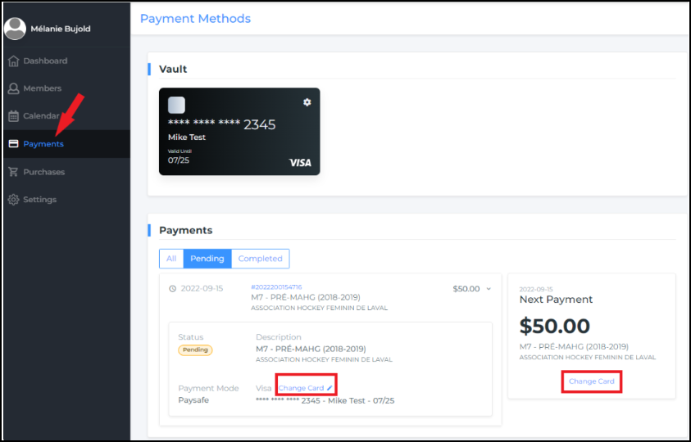
A new window will open, click on +Add a card.
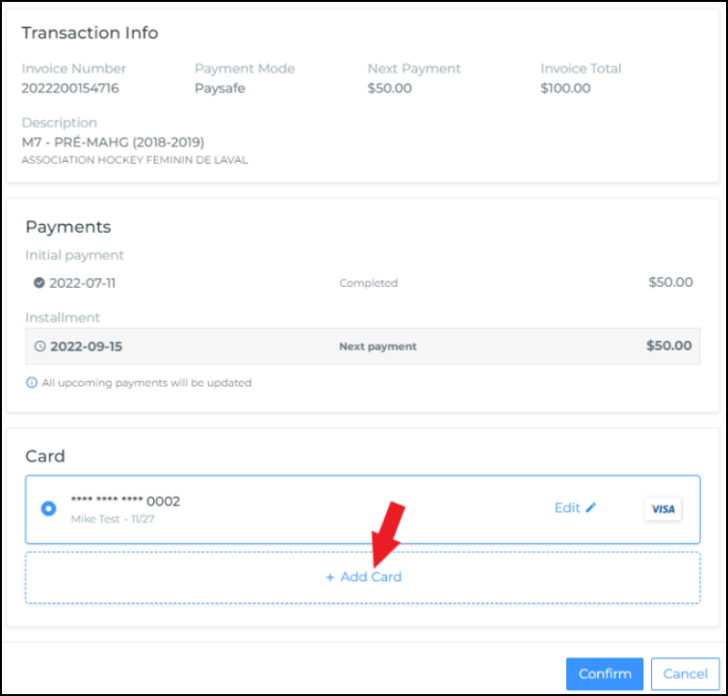
Update your credit card information and click Confirm.
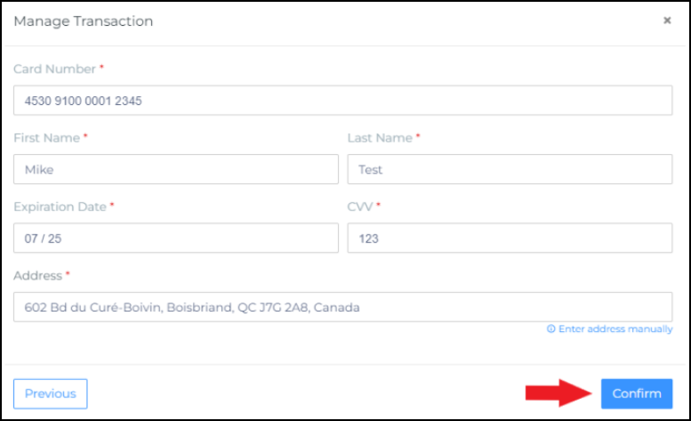
You will now have two cards available in your account. Select the new card you have added and click on Confirm.
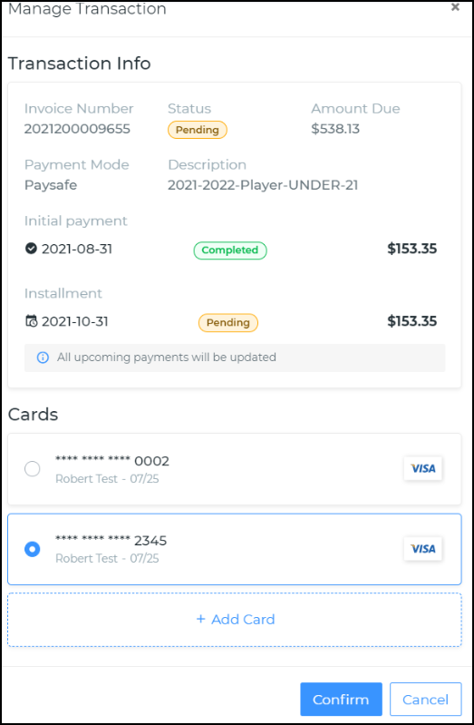
You have now successfully updated the card for the intended payment.
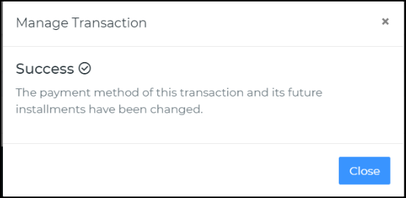
You will now also see 2 cards in your vault.
