Registration Process for Rowans Law for Coaches and Bench Staff

Here are the steps a coach or bench staff would take to sign up for Online Registration. NOTE: You only have to register once, even if you may be on different teams in different roles. They may not be allowed to register more than once depending on the MHA settings.

London Bandits
Our link https://registration.hockeycanada.ca/Registration/AccountLogin.aspx

Please note coaches that have been with the system longer than 2013 will have to recreate a user name and password, it will later than link your account with the existing one in the system.

Any coaches that have registered their kids will use the same account, just select yourself as coach or bench staff.

If you have forgotten your password, the system will send you a confirmation of your password to your email please check your junk or spam files in case it goes into there. Please note it would have to match the database that is existing from previous years.

Coach/Bench staff person will use the link and create an Online Registration account if they don’t have one already. NOTE: They can register themselves and kids at the same time if they wish.

Once in the Registration website, they can search for their HCR profile and click Register now: Depending on the participant age, they may only see one registration type. For both Coaches or Bench Staff, select the Bench Staff “Registration Type”.
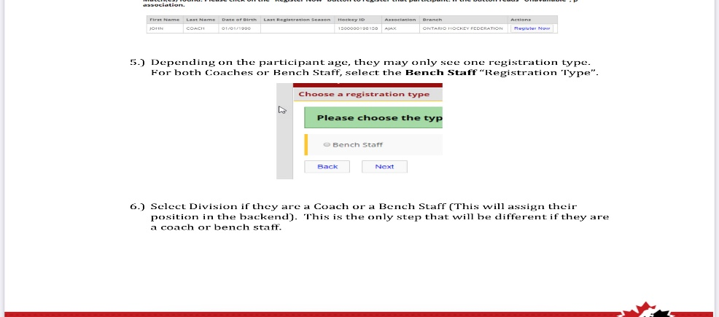

Select Division if they are a Coach or a Bench Staff (This will assign their position in the backend). This is the only step that will be different if they are a coach or bench staff.

The package will show up, there should be only one choice at this point.

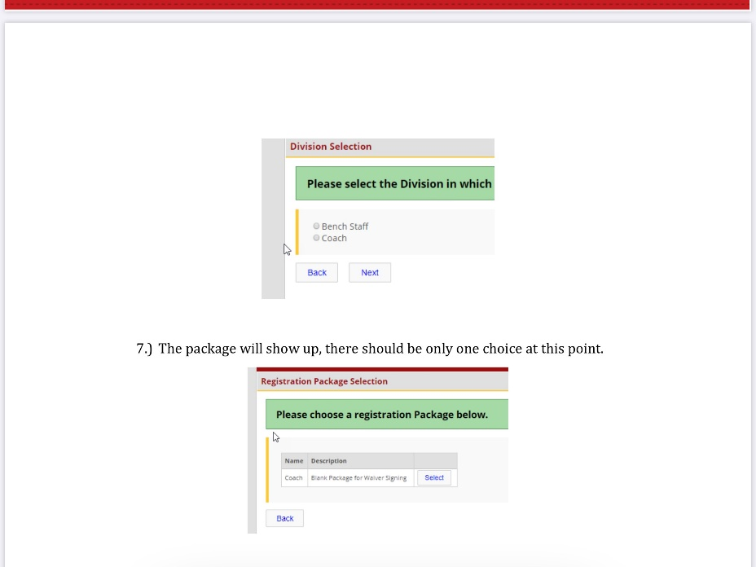

Next they will have to fill out some personal information, for address and emergency contact:
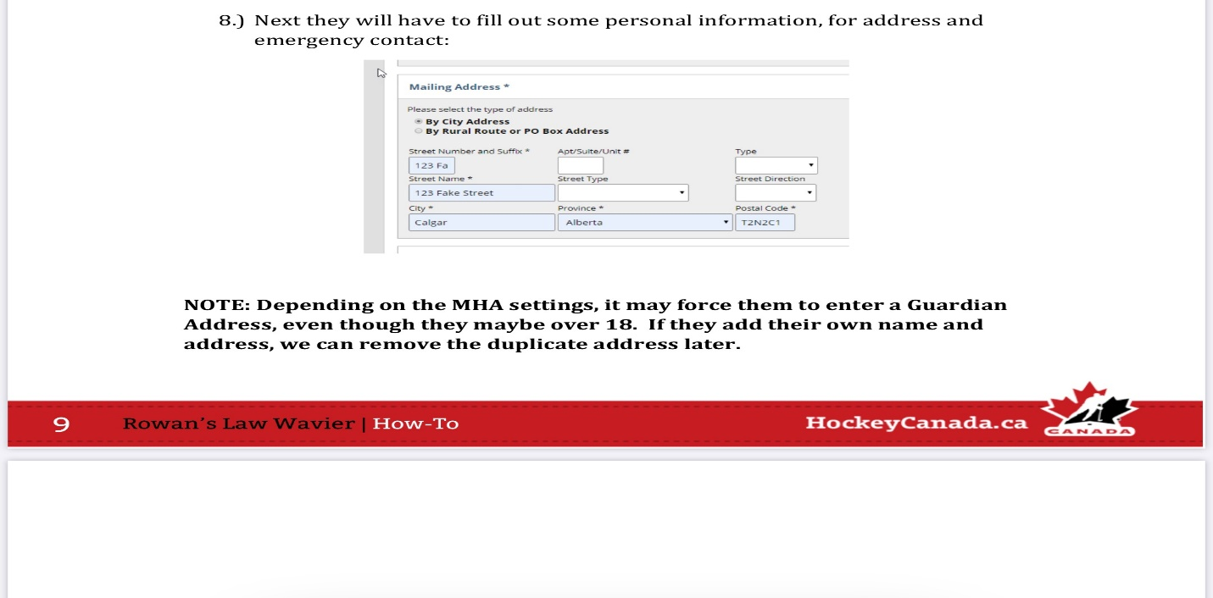

NOTE: Depending on the MHA settings, it may force them to enter a Guardian Address, even though they maybe over 18. If they add their own name and address, we can remove the duplicate address later.

Please also note if you created a new account, it will search for you as a member and it will merge the two identities at this point. Please write down your username and password some where safely.
FYI This is not the same as your e -locker username and password.

After this they will be asked the review and acknowledge the Rowan’s Law
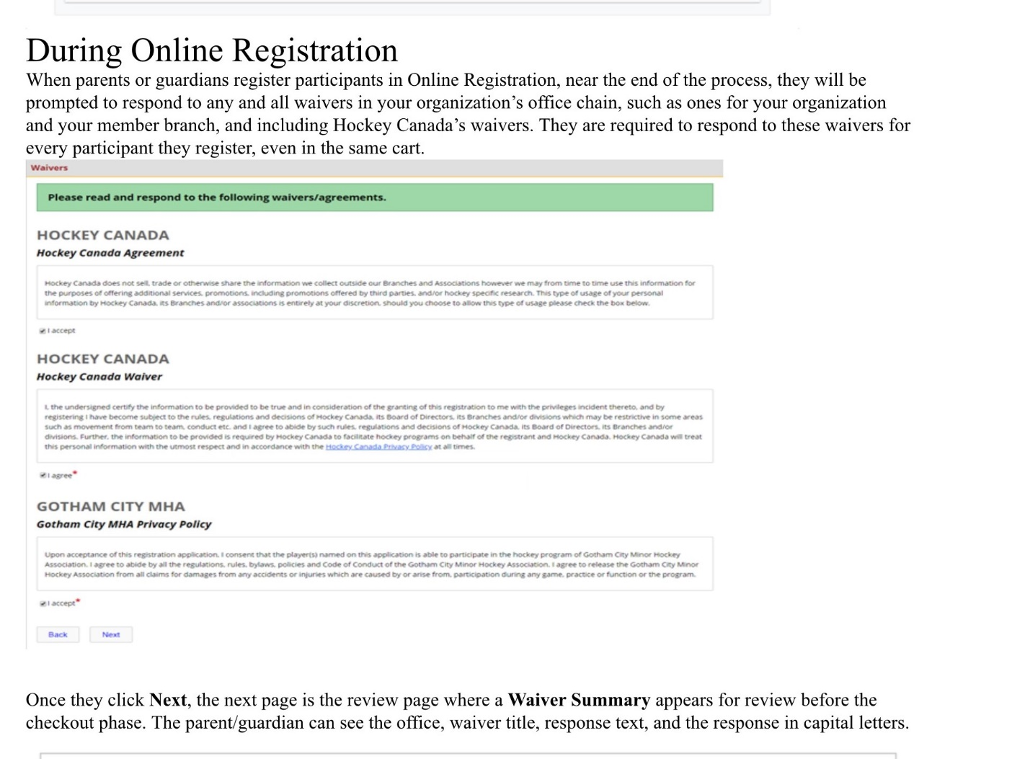

They can’t move forward until selecting the checkbox.

10.) There order will show up as $0 fees

11.) They can then add it to their cart. They can move forward and add other things into their cart if they wish, such as a child’s registration. Or if they wish to finish, they can proceed to check out:
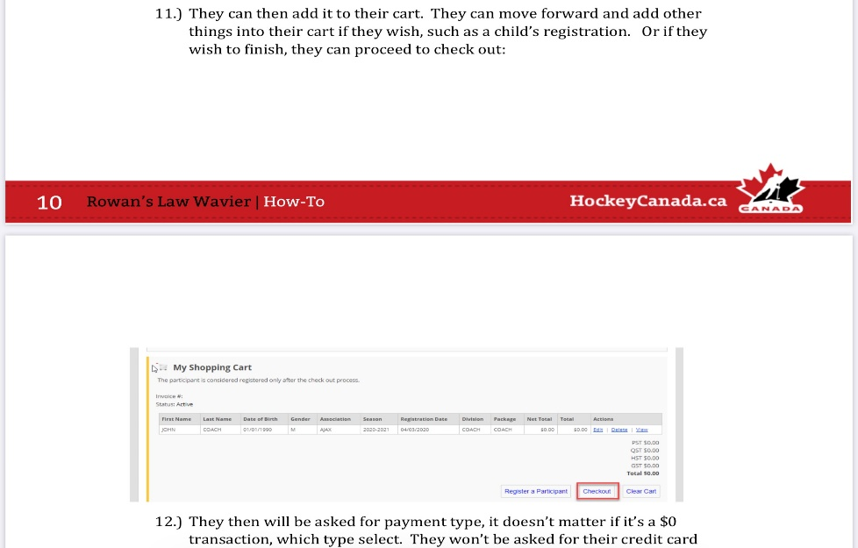

12.) They then will be asked for payment type, it doesn’t matter if it’s a $0 transaction, which type select. They won’t be asked for their credit card number, unless they have other packages in their cart.

13.They will then see as successful message indicating that the transaction was completed. • The package and division should so up as Coach or Bench Staff. • Steps are the same for Coach and Bench Staff.

14. On the HCR Side the accepted Waiver will appear on their profile, along with an entry in the Preregistrations ( Coaches/bench staff may not see this only registrars will )

15. Please note you will get an email in your inbox but it will not show that its for rowans law. All it will show is that 0.00 total.

Please note all fields must be completed in order for it to move to another field.

